P!NG
User Manual
IR Convolution Reverb · macOS Audio Unit
V 1.6.0

1. Overview 3
2. Main Interface 3
2.1 Top Row 3
2.2 IR Selection & Waveform 4
2.3 Mix & Reverb Controls 4
2.4 Stereo & Modulation 4
2.5 IR Input 4
2.6 Early Reflections & Tail Balance 5
2.7 EQ Section 5
3. IR Synthesiser 6
3.1 Character Tab 6
Surface Materials 6
Contents 7
Interior Architecture 7
Options 7
3.2 Placement Tab 8
Room Shape 8
Dimensions (metres) 8
Floor Plan 9
3.3 RT60 Display 9
3.4 Bottom Bar 9
4. Technical Explanation: How the IR Is Synthesised 9
4.1 Overview 10
4.2 Image-Source Method 10
4.3 Per-Band Rendering 10
4.4 Diffusion 10
4.5 Late Reverb (FDN Tail) 11
4.6 Output 11
4.7 RT60 Calculation 11
5. IR File Location & Formats 11
6. Presets 12

1. Overview
P!NG is an impulse response (IR) reverb plugin for macOS. It convolves your audio with IR files to add reverb, and includes a built-in IR Synthesiser to generate new IRs from room geometry, materials, and speaker/mic placement from first principles.

2. Main Interface
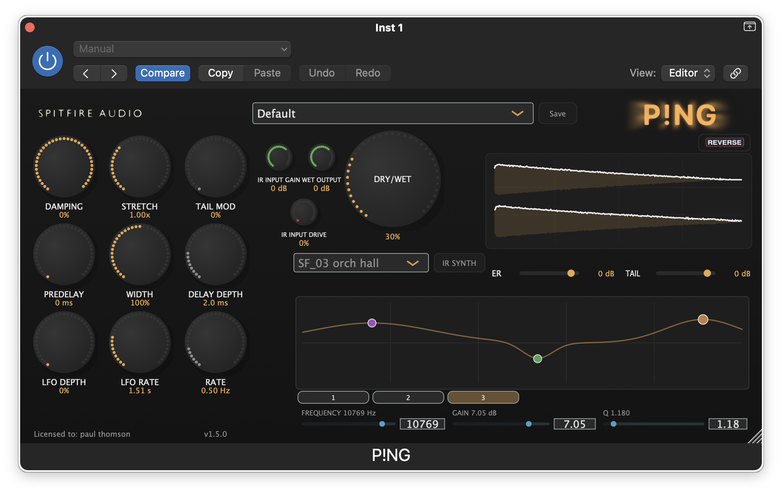Screenshot: Main P!NG interface — top row (preset, metres), centre knobs, IR selector, waveform, and EQ

2.1 Top Row
Element | Description
Preset menu | Load or save presets. Presets store all settings including IR choice and IR Synth parameters. Overtype in the box to create a new name.
Save preset | Saves the current settings under the name shown in the preset box (editable).
Output level metres | Visual feedback of wet output level.

2.2 IR Selection & Waveform
Control | Range | Description
IR dropdown | — | Choose an IR from your folder. Synthesized IR appears when you have just created an IR with the IR Synth and have not yet saved it.
IR Synth button | — | Opens the IR Synthesiser page.
REVERSE | Toggle | Time-reverses the IR for preverb-style effects.
Waveform display | — | Shows the current IR. In reverse mode drag the trim handle to trim the start of the IR.

2.3 Mix & Reverb Controls
Control | Range | Description
Dry / Wet | 0–100% | Balance between dry (original) and wet (reverb) signal.
Predelay | 0–500 ms | Delay before the reverb starts.
Damping | 0–100% | High-frequency damping. Higher values produce a more dull decay.
Stretch | 0.5–2.0 | Time-stretches the IR. 1.0 = no change.

2.4 Stereo & Modulation
Control | Range | Description
Width | 0–2 | Stereo width of the wet signal. 1 = normal; below 1 = narrower; above 1 = wider.
LFO Depth | 0–1 | Depth of LFO amplitude modulation applied to the tail.
LFO Rate | 0.01–2 Hz | Speed of the LFO modulation.
Tail Mod | 0–1 | Amount of delay/chorus modulation on the reverb tail.
Delay Depth | 0.5–8 ms | Modulated delay depth.
Rate | 0.05–3 Hz | Rate of tail modulation.

2.5 IR Input
Control | Range | Description
IR Input Gain | −24 to +12 dB | Gain applied to the IR input signal before convolution.
IR Input Drive | 0–1 | Saturation/drive before convolution. Higher values add harmonic warmth.
Wet Output | −24 to +12 dB | Gain applied to the Wet IR output signal

2.6 Early Reflections & Tail Balance
Control | Range | Description
ER (Early Reflections) | −48 to +6 dB | Level of the early reflection portion of the IR. (<85ms)
Tail | −48 to +6 dB | Level of the late reverb tail. (>85ms)

Use these controls to rebalance IRs that have strong early or late content.

2.7 EQ Section
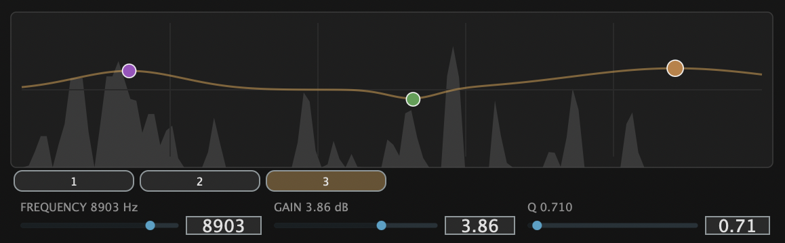Screenshot: EQ graph with three parametric bands
A 3-band parametric EQ shapes the wet reverb signal:
- Band 1 — Default 400 Hz, variable Q (0.3–10). Cut or boost the low-mid range.
- Band 2 — Default 1 kHz, variable Q. Mid control.
- Band 3 — Default 4 kHz, variable Q. High-mid / presence.

Click band buttons 1, 2, or 3 to select a band; drag on the graph to adjust frequency and gain, or use the sliders when they appear. The wet signal is animated behind the UI controls.

3. IR Synthesiser
Click the IR Synth button to open the synthesiser page.
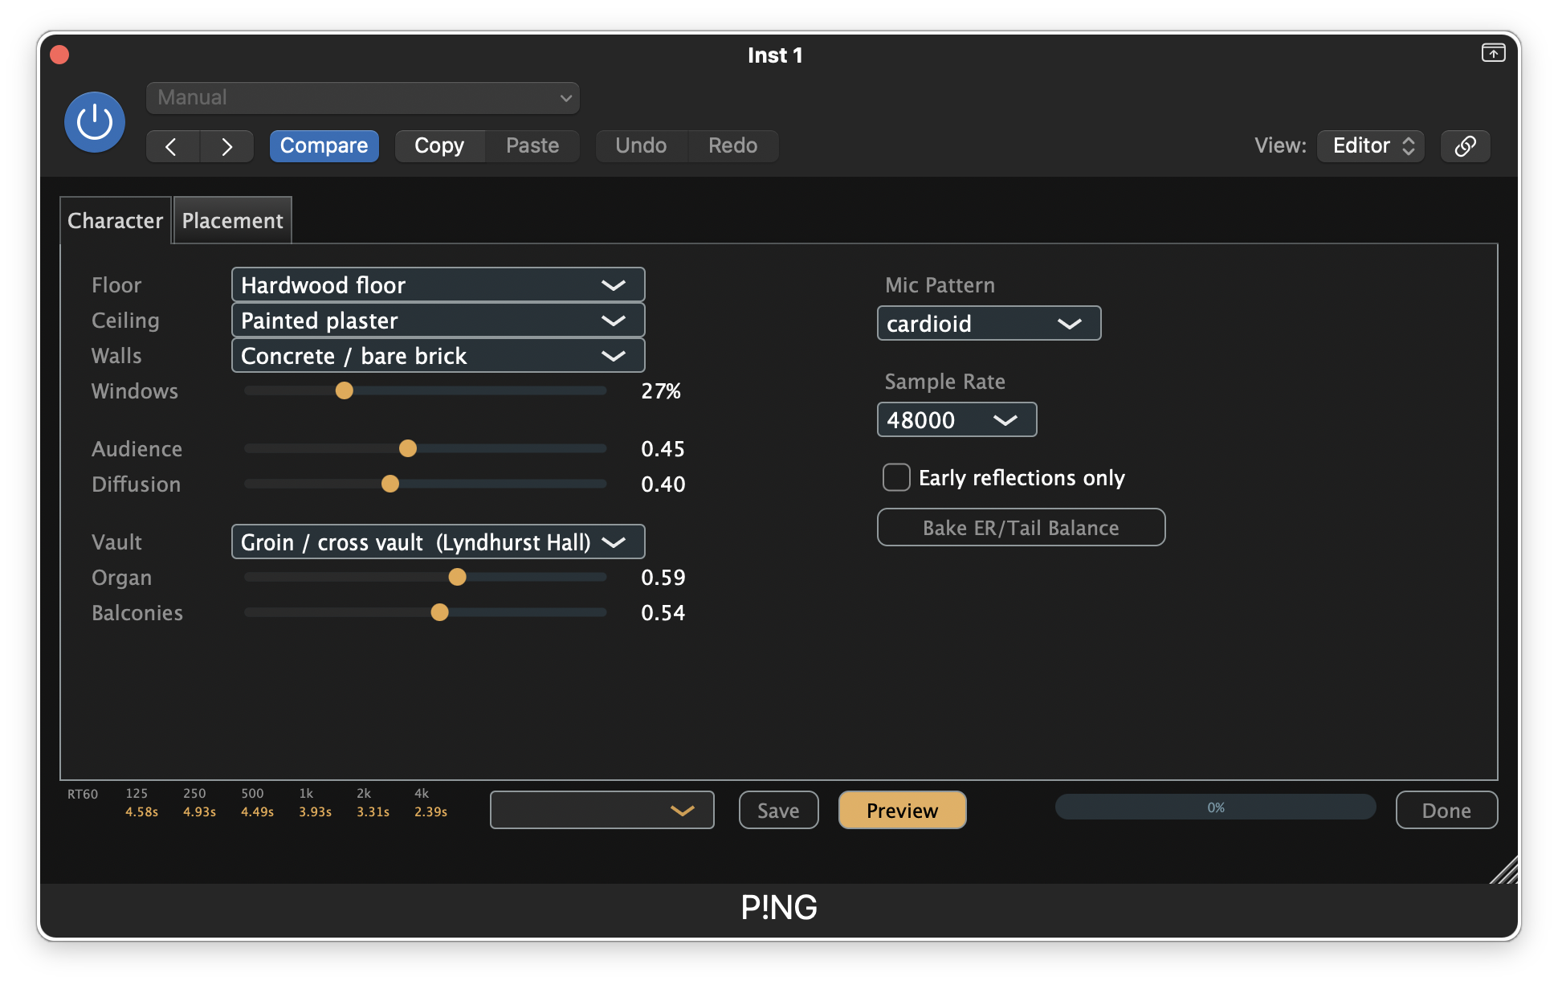Screenshot: IR Synth page — Placement and Character tabs, floor plan, bottom bar

3.1 Character Tab

Surface Materials
14 materials are available per surface, each with absorption coefficients defined across six frequency bands (125, 250, 500, 1k, 2k, and 4k Hz):
Material | Typical Use
Concrete / bare brick | Very reflective.
Painted plaster | Moderately reflective.
Hardwood floor | Reflective floor surface.
Carpet (thin/thick) | Absorptive floor surface.
Glass (large pane) | Reflective; frequency-dependent behaviour.
Heavy curtains | Highly absorptive.
Acoustic ceiling tile | Absorptive ceiling.
Plywood panel | Moderately absorptive.
Upholstered seats | Very absorptive (audience seating).
Bare wooden seats | Reflective seating.
Water / pool surface | Special case.
Rough stone / rock | Moderately reflective.
Exposed brick (rough) | Reflective.

Control | Range | Description
Windows | 0–100% | Usage: 0% Pure wall material (eg: brick, plaster)  100% Fully glazed (large glass pane)  Eg. 50% Mixed walls, half windows.

Contents
Control | Range | Description
Audience | 0–1 | Amount of audience absorption on the floor.
Diffusion | 0–1 | Scattered/diffuse reflections. Higher = smoother, less specular.

Interior Architecture
Control | Description
Vault type | Ceiling geometry: None (flat), Shallow barrel, Deep pointed (gothic), Groin/cross vault, Fan vault, Coffered dome.
Organ case | 0–1. Absorption/scattering from organ case furniture.
Balconies | 0–1. Absorption and geometry effect from balconies.

Options
Control | Options | Description
Mic pattern | omni, subcardioid, cardioid, figure-8 | Simulated microphone polar pattern.
Early reflections only | Toggle | Renders only early reflections — no FDN tail.
Sample rate | 44.1 kHz, 48 kHz | Output sample rate of the synthesised IR.

3.2 Placement Tab
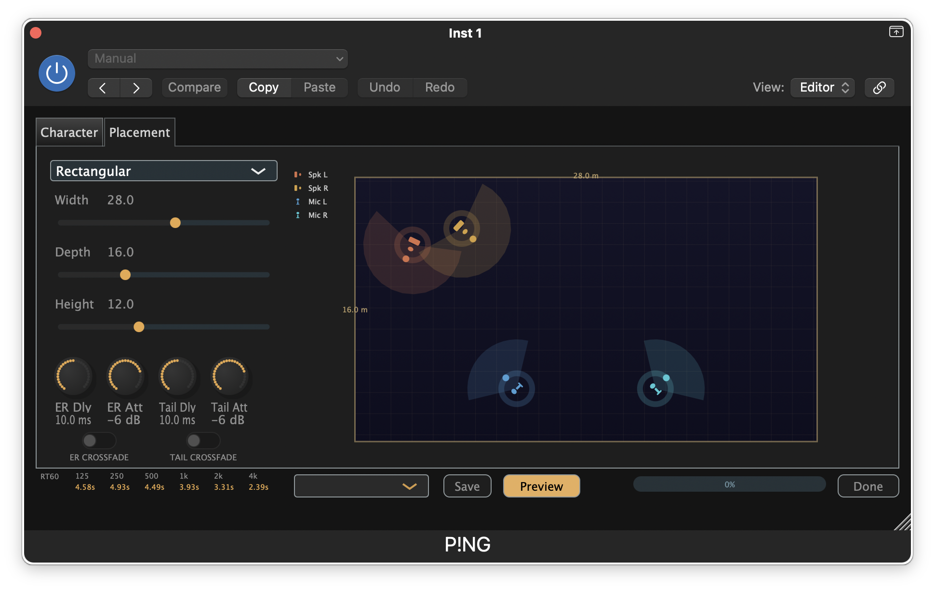Screenshot: Placement tab — room shape, dimensions, floor plan

Room Shape
Option | Description
Rectangular | Standard box room.
L-shaped | L-shaped floor plan.
Fan / Shoebox | Tapered or shoebox theatre style.
Cylindrical | Circular/cylindrical room.
Cathedral | Large cathedral-like space.
Octagonal | Octagonal floor plan.

Dimensions (metres)
Control | Range | Description
Width | 0.5–50 m | Room width.
Depth | 0.5–50 m | Room depth.
Height | 1–30 m | Room height.

Values can be typed into the number labels next to each slider.

Floor Plan
The floor plan shows speaker and microphone positions for the current room:
- Left/Right speakers (orange pucks) — Source positions.
- Left/Right mics (blue pucks) — Receiver positions.

Drag pucks to reposition them. Drag the small handle on each puck to rotate the speaker aim or microphone direction. Positions and angles affect early reflections and the stereo image.

Post Convolution Crossfade
The Early Reflections and Tail can be independently crossfaded LR-RL so that each channel cross feeds the other: so they can be independently tight or wide. Increasing the crossfade decreases the effect of the localisation and makes the reverb more stereo balanced.
- ER/Tail Dly – the amount of delay before the onset of crossfade
- ER/Tail Att – the amount of attenuation applied to the crossfade

3.3 RT60 Display
The IR Synth shows estimated RT60 (reverberation time) at six frequencies: 125, 250, 500, 1k, 2k, and 4k Hz. These values update as you change materials, dimensions, and room contents.

3.4 Bottom Bar
Control | Description
IR pick list | Load an existing 4-channel IR from the IR folder. Type a name into the box before saving a new IR.
Save | Saves the current IR to the IR folder under the name you have entered.
Preview | Renders the IR and loads it into the plugin. Stays on the IR Synth page.
Done | Returns to the main UI. If you have used Preview, the main UI will show "Synthesized IR".

4. Technical Explanation: How the IR Is Synthesised
P!NG's IR Synthesiser models a room with a geometric acoustic engine and produces a true-stereo, 4-channel impulse response (Left→Left, Right→Left, Left→Right, Right→Right) for convolution reverb.

4.1 Overview
The engine uses four main stages:
- Image-source method — Mirror sources for early reflections.
- Per-band rendering — Six octave bands for frequency-dependent absorption.
- Allpass diffusion — Smooths reflections.
- FDN tail — 16-delay feedback delay network for the late reverb.

4.2 Image-Source Method
The room is treated as a box (with floor-plan and vault modifiers). Virtual sources are placed by mirroring the real source across the floor, ceiling, and walls. Each reflection has a delay from path length (distance / speed of sound), plus per-band amplitudes derived from:
- Distance attenuation (1/distance)
- Floor and ceiling absorption (from material coefficients)
- Wall absorption (from material coefficients)
- Air absorption (high-frequency loss)
- Mic polar pattern — gain from arrival angle vs mic orientation
- Speaker directivity — modelled as cardioid
- Polarity — flipped on odd reflection orders

Room shape (rectangular, L-shaped, cylindrical, etc.) changes the density and spatial distribution of these reflections.

4.3 Per-Band Rendering
Materials are defined by absorption coefficients at 125, 250, 500, 1000, 2000, and 4000 Hz. The engine:
- Splits reflections into six frequency bands.
- Applies band-specific absorption for each reflection.
- Filters each band with a bandpass filter centred on each frequency.
- Sums the bands into a single time series per channel.

This produces frequency-dependent decay — for example, shorter high-frequency and longer low-frequency reverberation times.

4.4 Diffusion
A 4-stage allpass diffusion network is applied to the summed signal. Higher diffusion:
- Increases delay density and smooths the time response.
- Reduces flutter echo and specular "pinging" artefacts.

4.5 Late Reverb (FDN Tail)
For the late tail (after approximately 85 ms):
- The early portion (0–85 ms) is taken from the image-source result.
- A 16-line feedback delay network (FDN) is seeded with this early energy.
- Delays are prime-numbered and scaled by room volume and surface area (mean free path).
- LFO modulation (±1.2 ms) on the delays reduces metallic resonances.
- Hadamard mixing distributes energy evenly across the 16 lines.
- Per-line lowpass filters give each line its own decay rate (from RT60 curves), so high frequencies decay faster than low frequencies.
- The early and tail portions are crossfaded around 85 ms.

The Early reflections only option skips the FDN and outputs only the image-source portion.

4.6 Output
The result is a 4-channel impulse response:
Channel | Path
iLL | Left speaker → Left mic
iRL | Right speaker → Left mic
iLR | Left speaker → Right mic
iRR | Right speaker → Right mic

Each channel is band-limited (20 Hz–18 kHz), level-adjusted with a fixed output trim, and written as 24-bit WAV. A .ping sidecar file stores the synthesis parameters for recall.

4.7 RT60 Calculation
RT60 is estimated using the Eyring equation:
T = 0.161 × V ÷ (−S × ln(1 − α))
Where V is the room volume, S is the total surface area, and α is the mean absorption coefficient. Air absorption is added at high frequencies. Audience, balconies, and organ case contribute additional absorption terms.

5. IR File Location & Formats
Item | Details
Folder | ~/Documents/P!NG/IRs
Formats | .wav, .aiff, .aif
Synthesised IRs | 4-channel WAV (24-bit). The IR Synth pick list shows only 4-channel files.
Sidecar files | .ping files store synthesis parameters alongside the .wav for recall of room, materials, and placement.

6. Presets
Presets are stored in ~/Documents/P!NG/Presets/ and capture the complete state of the plugin:
- Main UI parameters (dry/wet, predelay, damping, stretch, width, and more)
- IR selection (file-loaded IR or Synthesized IR)
- IR Synth parameters (room shape, dimensions, materials, and placement)
- EQ settings

